The Gift of Giving: Teaching Students the Importance
of Generosity and Compassion

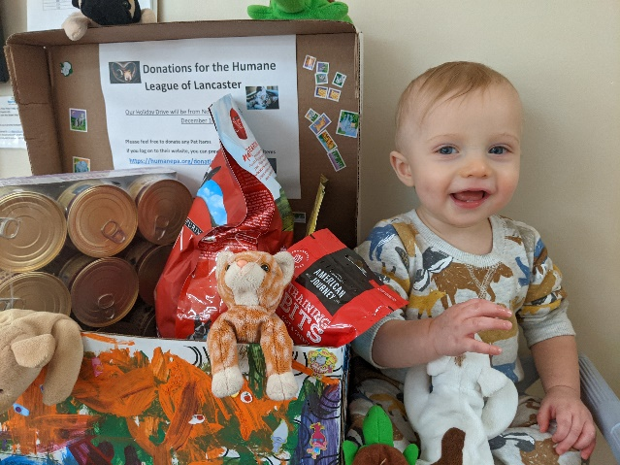
The holidays are a wonderful time of year for many reasons. We enjoy spending this time with our students as we reflect on the past year, learn about different traditions, and give back to those in need. Our annual holiday giving initiative is a way for students to build the important foundation of generosity and compassion. Through this event, they develop an appreciation for what they have, show gratitude towards others, and see the positive impact of their actions. It brings a smile to our faces to see our students get so excited to lend a helping hand.
Below are just a few ways we’re helping our communities this season.
- Students will collect toys, art supplies, games, books and other gifts for children in need. These special items will be delivered to Toys for Tots, local shelters, and children’s hospitals.
- During Thanksgiving, many of our students collected nonperishable food items. They will continue their collections throughout December, tour the food banks, and learn about how their contributions will make a difference in their community.
- Students will help stock the shelves of local shelters by collecting essential winter accessories, such as coats, mittens, hats, and blankets.
- The gift of time is precious. Students will make cards and visit senior centers to spread holiday cheer. They will enjoy snacks with residents, make holiday decorations, read books, and sing carols.
- Students will show their appreciation for community helpers by delivering baked goods. They’ll measure and mix ingredients, roll the dough, place the baked goodies in boxes, and deliver them with handmade cards.

