5 Easy STEM Activities to Try This Month at Home
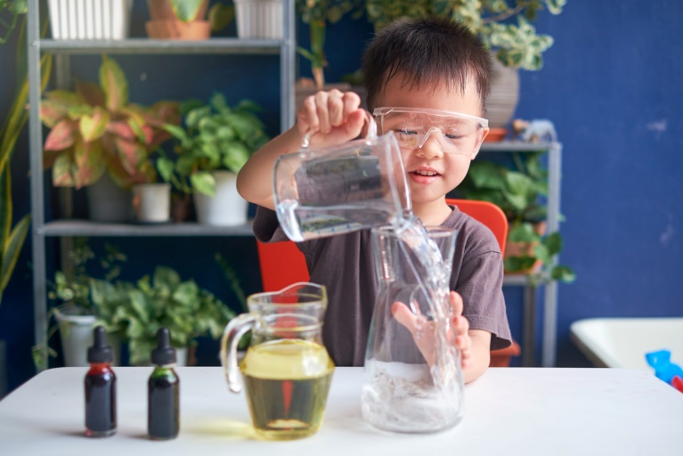
Did you know… National STEM/STEAM Day is November 8th! We believe that introducing these concepts in preschool is important to help children build problem-solving, reasoning, and critical thinking skills, as well as self-confidence and self-direction.

All year long, our students work collaboratively to create vehicles using cardboard boxes, make containers to grow plants, and build cities out of blocks. They use hands-on materials to explore and understand math concepts such as pattern, size, and shape. They even become mini scientists by making predictions, experimenting, and charting their results.

Below are a few ways to continue STEM/STEAM education at home.

- Chia Seed Jar
Gather a mason jar, a cup of water, and a teaspoon of chia seeds. Ask your child to place the chia seeds into the jar and pour the water on top. Assist if needed. Cover the top of the jar with a cheesecloth and secure with a rubber band. Let the jar sit overnight. The next day, drain the water. The chia seeds should begin sprouting in a few days. Ask your child to predict how tall the seeds will grow and record the results.
- Baking Soda Art
Cover the bottom of a tray with baking soda. In a separate bowl, add vinegar and food coloring. Using a dropper, ask your child to pick up the vinegar and drop it into the baking soda. They’ll love watching the fizzy experiment. Use different shades of food coloring and encourage your child to create unique art in the tray.
- Sink or Float Experiment
Fill a large bin or bathtub with water. Provide your child with various seasonal items, such as pinecones, leaves, and mini pumpkins. Ask them to predict whether each object would sink or float. Conduct the experiment to see if their hypotheses were correct.
- Unique Creations
No need to go shopping! Use materials found around your home to design and build unique creations. Some easy ideas include making binoculars with toilet paper tubes and tape, building a fort using pillows, assembling a tower from magazines, and creating a necklace using macaroni and string.
- Ice Melting Activity
Conduct an experiment to see where ice would melt the fastest inside your home. Place ice cubes in bowls in different rooms, such as a bedroom, the kitchen, and garage. Ask your child to predict which bowl of ice would melt the fastest.

