October 2022
Breakfast and Snack Menu

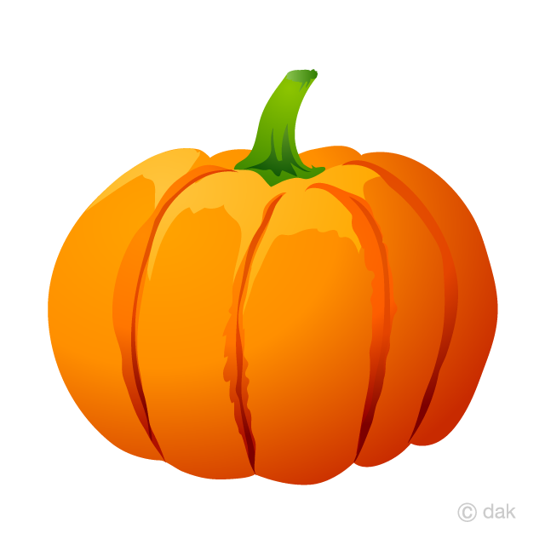
3 Bagels & Cream Cheese, fruit, milk  Graham Crackers | 4 Cheese Quesadillas, fruit, milk  Applesauce | 5 Cereal, milk, fruit  Animal cookies | 6 Mini Muffin, milk, fruit  Wheat Thins | 7 Biscuit & Jelly, milk  Cheez-itz
10 Cheese Quesadillas, fruit, milk  Applesauce | 11 Cereal, milk, fruit  Animal cookies | 12 Mini Muffin, milk, fruit  Wheat Thins | 13 Biscuit & Jelly, milk  Cheez-itz | 14 Bagels & Cream Cheese, fruit, milk  Graham Crackers
17 Cereal, milk, fruit  Animal cookies | 18 Biscuit & Jelly, milk  Cheez-itz | 19 Oatmeal, milk, fruit  Wheat Thins | 20 Bagels & Cream Cheese, fruit, milk  Graham Crackers | 21 Cheese Quesadillas, fruit  Rice pudding
24 Mini Muffin, milk, fruit  Wheat Thins | 25 Pancakes, milk, fruit  Pears | 26 French Toast, milk, fruit  Sliced Apples | 27 Cereal, milk, fruit  Ritz Crackers | 28 Cheese Quesadillas  Rice Pudding
31 Biscuit & Jelly, milk

Applesauce

