4 Easy Hands-On Valentine’s Day Activities for Your Preschooler
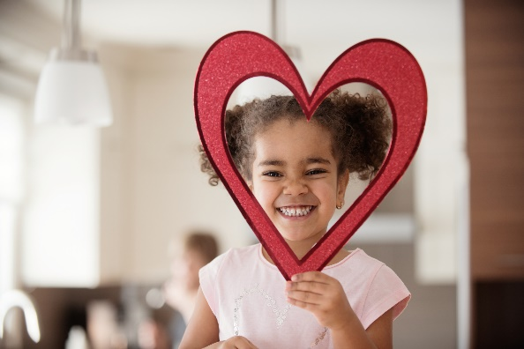
Holidays are great opportunities to make new traditions and memories with your family. This month, we’ve compiled four of our favorite Valentine’s Day themed activities perfect for children of all ages.
- Valentine’s Day Sensory Bin
Grab a bin and fill it with items found around your home or at your local craft or grocery store. Some ideas include pink sand, candy conversation hearts, plastic spoons, small toy shovels, rice, feathers, beads and shredded paper. Your child will have a blast scooping, digging, pouring and sorting the objects.
- Play Dough Fun
Open-ended toys like play dough help children explore and create without the pressure of doing things the right or wrong way. Lay out a tray for your child and give them play dough, heart shaped cookie cutters, a small rolling pin and items to press into the dough, such as toothpicks, beads or dry pasta shells.
- Cards for Loved Ones
Traditional paper valentines are not only festive but are also a precious keepsake for loved ones. Provide your child with paper, crayons, paint, markers, stickers, and other supplies, and let their creativity run wild! Encourage older children to use uppercase and lowercase letters. Show enthusiasm in any effort, as this is how they learn that words are powerful and have meaning.
- Friendship Bracelets
A great way to focus on friendship and love this month is to make friendship bracelets. Making jewelry fosters creativity, while also practicing pattern recognition, concentration and fine motor skills. Give your child red, white and pink beads and yarn or pipe cleaners. When you child is finished making the bracelet, ask them to count the total number of beads used. You can extend the activity by also accompanying the bracelet with a homemade card, as mentioned above.

