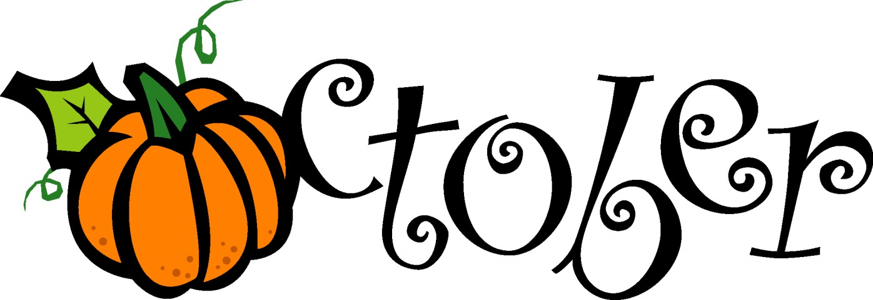
It’s officially fall! We have made it to the last 3 full months of the year! There are some exciting events happening in our school this month…
Summer will be out of the office from October 24th -28th for her annual principal’s conference in Las Vegas. She will be bringing back lots of exciting ideas and new information for our school! Please contact Rochelle (rochelle.buckley@nlcinc.com) or Sophie (sophie.wilkinson@nlcinc.com) for any needs you have.
Events for October:
October 3rd-7th: Breast Cancer Awareness week. Wear pink every day and show your support!
October 10th: School closed in observance of Columbus Day!
October 11th-13th: Picture Day! Below are classroom days as follows:
October 11th: Beginner’s and Infant Center
October 12th: Intermediates and Toddlers
October 13th: Pre-K and Kindergarten
October 31st: Happy Halloween! Dress up in your costume for our Halloween Bash! We will be having our annual school parade @ 10:30am to show off your costume and for some trick or treating fun! Parents are welcome to watch the parade and take pictures!

Important reminders in our center:
-Please do not leave your child unattended in your cars during drop off and pick up.
- Art class will be starting with Mrs. Jody on October 3rd for Pre-K and Kindergarten for a free trial. Registration packets will be going home after to sign up.
-We are approaching the cold and flu season we wanted to share some important information and guidelines from the Centers for Disease Control and Prevention (CDC):
You can help stop the spread of influenza and other diseases by doing the following things:
- If you get sick with flu-like illness, stay home for at least 24 hours after your fever is gone except to get medical care or for other necessities. (Your fever should be gone without the use of a fever-reducing medicine.)
- Practice proper cough and sneeze etiquette to prevent the spread of germs.
- Wash your hands regularly.
- Avoid touching your eyes, nose or mouth
- Clean and disinfect frequently touched surfaces at home, work or school, especially when someone is ill.

When will flu activity peak?
The timing of flu is very unpredictable and can vary from season to season. Flu activity most commonly peaks in the United States in January or February. However, seasonal flu activity can begin as early as October and continue to occur as late as May.

Below is a copy of Discovery Isle’s illness policy:
Your child should not be brought to the center if, within the last 24 hours, the child has had a fever diarrhea, a yellow or green runny nose, or other illness that could be given to children and teachers. Therefore, it is important that you have some kind of alternate care for your child on such occasions.
Discovery Isle encourages safeguarding the health of young children by requesting parents to follow these guidelines when deciding if a child is well enough to attend the center:
- Fever: Keep child home until fever registers below 100* for 24 hours and child is acting well.
- Runny Nose: Keep child home until thick yellow or green discharge clears up.
- Earache: Keep child home until doctor examines the ears and recommends the child to return to the center.
- Rash: Keep child home until doctor determines the cause and recommends the child to return to the center.
- Sore Throat: Keep child home until a doctor determines no strep infection exists and the throat is healed.
- Cough: Keep child home until coughing subsides.
- Upset Stomach/Vomiting/Diarrhea: Keep child home until symptom free for 24 hours and the child is eating normally without upset.
Please join together to help fight this cold and flu season by following these guidelines.

Thank you and happy fall,
Discovery Isle

