The Value of Visual Art Activities for Your Preschooler
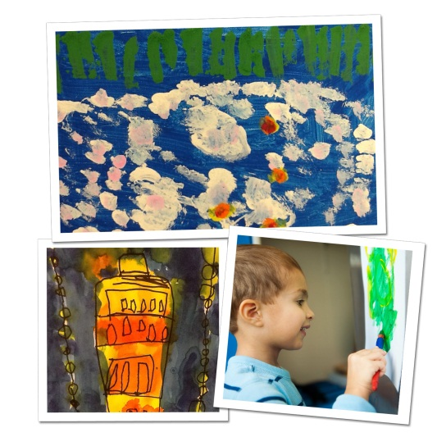
Visual art experiences help children develop skills such as critical thinking, self-expression, problem-solving, communication and collaboration. Our teachers focus on process-based art education, in which the experience of creating art is valued over the end product.
In our classrooms, teachers integrate art into many aspects of our Links to Learning curriculum. After reading a book about polar bears, teachers might ask students to create their own polar bears using sponges, paint, markers and paper. They encourage students to talk about their art, providing a great opportunity to learn new vocabulary, particularly words related to colors, shapes,textures, and emotions.
Our students are also exposed to and inspired by famous artwork. In order to cultivate that fascination, we discuss famous artists and art works and ask students to create replicas of well-known paintings and sculptures. For example, after learning about Michelangelo’s painting on the ceiling of the Sistine Chapel, teachers mimic the activity in the classroom. They tape paper underneath tables, and students practice painting a masterpiece while lying down.
Below are visual art activities you and your child can do at home, as well as recommended reading.
At Home:
- Provide your child with finger paint, a large piece of paper and a smock. Let him create a masterpiece. Talk about how the paint feels and what colors and shapes he creates on the paper.
- Start a journal with your child. Have him draw a picture of something that happened during the day. Avoid giving direction. Instead of saying “Draw a picture of your teacher and classmates,” encourage him to experiment using different colored markers or crayons. If age appropriate, ask your child to write a few words to describe the picture.
- Give your child a piece of paper and a box of crayons or markers. Show him how to use the materials to make dots, lines and swirls on the paper. Let him take over and have fun. Encourage conversation about your child’s art by saying, “Tell me about what you made” or “I see you used a lot of blue in your picture. Why did you choose that color?”
- Ask your child to decorate a sign for his bedroom door using various art materials. Have him write his name on the sign.
Recommended Reading:
- The Dot by Peter Reynolds
- Beautiful Oops by Barney Saltzberg
- Art by Patrick McDonnell
- Not a Box by Antoinette Portis
- Mix It Up by Herve Tullet
It is wonderful to share the joy that children naturally take in using art materials. Giving children extra opportunities to connect art to the world around them, contributes to happiness and future success in elementary school and beyond.
- Lauren Starnes, PhD – Director of Early Childhood Education

