Exploring Community Helpers & the Roles They Play
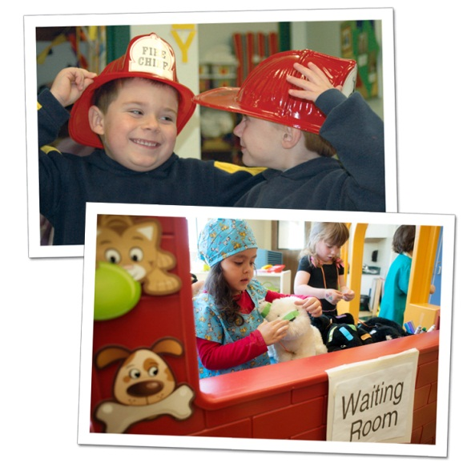
This month, our students are gaining a greater understanding of community helper occupations, such as police officers, mail carriers, medical professionals and firefighters. The children have a lot of fun imagining themselves in these important roles, and incorporating toy versions of the uniforms, equipment and vehicles that go with them.
In addition, October is National Fire Prevention Month, so we place a special emphasis on the importance of fire safety and the role of firefighters. Our classroom activities help the children become more comfortable around emergency responders in uniform, and teach them basics about what to do in case of an emergency.
Here are some ways children learn about community helpers in the classroom, as well as activities for you and your child to do at home.
TODDLERS (ages 1-2):
In the classroom: Toddlers are fascinated with dressing up as doctors, police officers and firefighters, because they have distinct uniforms and roles that children can easily understand. During dramatic play, our teachers provide students with costumes and props, and encourage them to choose the role they want to play.
At home: Continue dress-up play by providing your child with various props and costumes. Ask him, “Who do you want to dress-up as?” and “What does that person wear?”
Recommended reading: Whose Hat is This by Sharon Katz Cooper
BEGINNERS (ages 2-3):
In the classroom: Our Beginner students learn about the special vehicles that community helpers use, by playing matching games, reading books, and building vehicles using cardboard boxes.
At home: Go for a drive with your child. Point out vehicles that belong to community helpers, such as a fire truck and a police car. Ask, “Who drives that vehicle?” and “Where might it be going?”
Recommended reading: The Little Fire Engine by Lois Lenski
INTERMEDIATES (ages 3-4):
In the classroom: During fire safety lessons, many of our schools invite local firefighters to visit. Students explore the tools firefighters use, learn “Stop, Drop and Roll,” and may have the opportunity to tour a fire truck.
At home: Continue exploring fire safety by practicing “Stop, Drop and Roll” with your child. Ask him, “Who puts out fires?” and discuss what he should do if he hears a fire alarm at home.
Recommended reading: The Fire Engine Book by Tibor Gergely
PRE-K/PRE-K 2 (ages 4-5):
In the classroom: Teachers introduce situations when it might be necessary to dial 9-1-1. Students practice finding 9-1-1 on different keypads, such as cell phones and landlines.
At home: Show your child photos of various community helpers and the buildings where they work. Ask him to identify the helpers and their workplaces, and describe the roles the helpers play in our community.
Recommended reading: The Berenstain Bears: Jobs around Town by Jan Berenstain
We provide many opportunities for students to learn about community helpers. By setting this foundation, they become more familiar and comfortable around the people that make their neighborhoods a better place.
- Lauren Starnes, PhD – Director of Early Childhood Education

