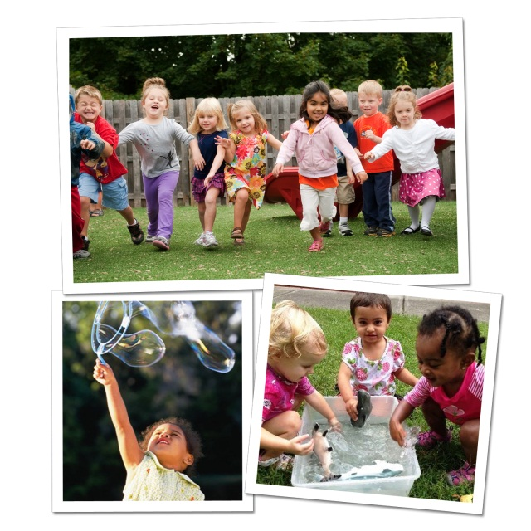
Fun Ways to Keep Your Child
Engaged in Learning this Summer
Summer offers unique opportunities for children to learn through fun, multi-sensory experiences. Our teachers continue to use our Links to Learning curriculum to help children develop new skills throughout the summer.
Here are some examples of types of activities we will be doing this summer, as well as ideas for you and your child to do at home.
INFANTS
In the classroom: Our teachers provide numerous opportunities for multi-sensory exploration. Infants spend tummy time in the grass, splash their hands at the water table and feel and taste summer fruits.
At home: Fill a small bowl with water and place it in front of your child. Allow him to splash his hands in the water. Practice hand-eye coordination and fine motor skill development by adding toys and encouraging your child to retrieve them.
TODDLERS (ages 1-2):
In the classroom: In the toddler years, children begin to play together with their peers. They practice sharing toys and cooperating in learning centers. Research shows that by nurturing connections with others, toddlers learn how to form friendships, communicate their emotions and deal with challenges.
At home: Encourage sharing skills by taking turns blowing bubbles with your child, doing the Hokey Pokey, or drawing pictures using sidewalk chalk.
BEGINNERS (ages 2-3):
In the classroom: Our Beginner students use math and science while participating in fun outdoor activities. For instance, they predict and test the buoyancy of toys at the water table, and count how many will float and how many will sink.
At home: During bath time or in a baby pool, continue the exploration of what sinks and what floats. Bring a small assortment of toys and ask your child to guess which items will sink or float.
INTERMEDIATES (ages 3-4):
In the classroom: Intermediates take advantage of the warm summer weather by strengthening their gross motor skills. They practice pedaling on a tricycle, throwing and catching balls, playing hopscotch and walking on balance boards.
At home: Play follow the leader around your neighborhood or at a nearby park. Have your child try skipping, galloping, hopping, marching and jogging.
PRE-K/PRE-K 2 (ages 4-5):
In the classroom: Teachers make reading and writing more engaging and fun by moving learning outdoors. For example, our older preschoolers go on a nature walk, write about their experience in their journals, and share their journal entries with the class.
At home: Increase your child’s interest in writing by bringing various writing materials outside, such as crayons and paper or colored sidewalk chalk. Ask your child to draw and label what he sees.

During the summer months, we provide many opportunities for students to explore their interests, learn to their full potential, and express themselves creatively. These hands-on experiences lead to growth in all areas of development as children transition into elementary school and beyond.
- Lauren Starnes, PhD – Director of Early Childhood Education

