Developing Writing Skills in Young Children
- From Crayons to Concepts -
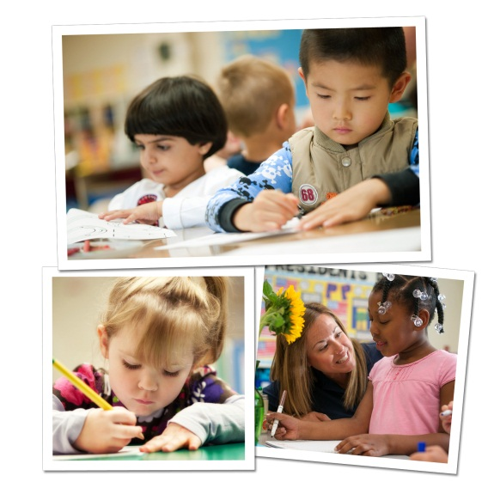
In the early preschool years, writing starts with practicing fine motor skills and progresses to include concepts such as vocabulary, sentence structure and inventive spelling. Our curriculum builds the foundation for writing beginning with our infants. Our teachers not only instruct students how to write, but they also help instill a love of writing and self-expression.
Below are activities we implement in our classrooms to get children excited about writing, as well as fun activities to try with your child at home.
INFANTS/TODDLERS
In the classroom: Our infants and toddlers practice picking up and placing objects into containers, building hand strength and coordination.
At-home activity: Give your child plastic cooking utensils, such as spoons and spatulas, along with a large bowl. Place appropriate finger foods in the bowl, and encourage your baby to pick up the utensils and use them to move the food around. Choose utensils with different sized handles so your baby learns how to grasp and hold objects in various ways.
BEGINNERS (Ages 2-3)
In the classroom: During imaginative play, teachers provide pens, markers and crayons to encourage students to practice writing. For instance, they pretend to own a restaurant and write food orders, and pretend to be doctors and take notes about the condition of their stuffed animals.
At-home activity: Incorporate writing activities during playtime. Bring sidewalk chalk outdoors and ask your child to write what they see. Don’t correct spelling or proper letter formations. Show enthusiasm in any efforts he makes, as this is how children learn that words are powerful and have meaning.
INTERMEDIATES (Ages 3-4)
In the classroom: Different writing tools and surfaces make writing more interesting for children. Our Intermediates use chalk on a chalkboard, form letters using modeling clay, and finger paint on canvas.
At-home activity: Three year olds enjoy mimicking adults in their daily activities. Allow your child to engage in a new writing activity with you, such as writing a grocery list or a thank you card. Explain to him what you are writing and the purpose it serves.
PRE-K/PRE-K 2 (Ages 4-5)
In the classroom: Teachers make writing fun for our older preschoolers by creating a classroom post office and asking the children to write and mail letters to each other. Through this activity, students practice communicating thoughts and ideas on paper, using proper grip, writing first and last names in correct case, and writing words independently by using inventive spelling. Inventive spelling encourages a love for writing and reinforces phonics. Traditional spelling is encouraged as students move into more formal writing in early elementary grades.
At-home activity: After a family outing, invite your child to write about his day in a journal. Encourage him to use uppercase and lowercase letters. If he asks for help writing more challenging words, have him attempt to spell them by sounding out the word and writing the letters that make that sound. Invite him to read his journal entry to you.
We provide many opportunities for our preschoolers to develop and practice their writing skills. By setting this foundation, they will be better prepared to communicate thoughts and ideas through writing in elementary school and beyond.
- Lauren Starnes, PhD- Director of Early Childhood Education

