Appreciating the Wonders of Mother Nature
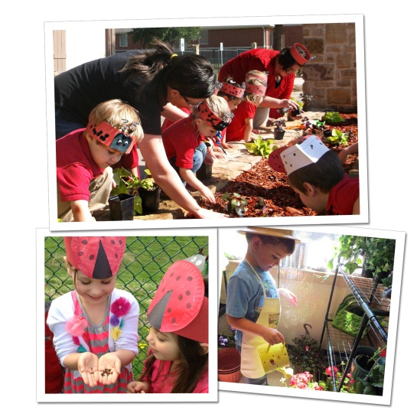
Spring is here and Earth Day is right around the corner, providing a wonderful opportunity to connect children with nature and reinforce the importance of preserving and protecting the world around us.
Our Links to Learning curriculum uses hands-on activities to cultivate a deeper connection to the earth and foster academic, physical and social skill development.
Below are activities we implement in our classrooms to get children excited about nature, as well as activities and books to read with your child at home.
INFANTS/TODDLERS:
In the classroom: Our teachers provide natural objects, such as leaves, pinecones and flowers for the children to see and touch. We help children associate words with the concrete objects they represent.
At-home activity: Allow your child to experience different textured fruits, such as an orange, watermelon and cantaloupe. Talk about what he sees, smells, tastes and feels.
Recommended reading: Colors from Nature from PlayBac Publishing and The Earth Book by Todd Parr
BEGINNERS (Ages 2-3):
In the classroom: Around age two, children begin to understand interdependencies in nature. For instance, they learn that ladybugs feed on insects that are harmful to gardens, trees and shrubs. On Earth Day, many of our students have the opportunity to release ladybugs to help local gardens.
At-home activity: Take a walk outdoors with your child and play a game of “I Spy.” Ask him point out objects found in the springtime, for example a red flower, a blue bird or a colorful butterfly.
Recommended reading: Biscuit’s Earth Day Celebration by Alyssa Satin Capucilli & David T. Wenzel and The Very Hungry Caterpillar by Eric Carle
INTERMEDIATES (Ages 3-4):
In the classroom: As our Intermediates gain a greater understanding and appreciation for how living things grow, the class may adopt a pet such as a fish or bunny. Students develop math, science and language skills by measuring the pet’s food, observing the pet’s behavior and habitat, and learning new vocabulary. Research shows that when children have the opportunity to care for animals, they practice nurturing behaviors that help them interact in gentle ways with people also.
At-home activity: Create a small garden and allow your child to help you plant and water seeds, either outdoors or indoors. Ask him to predict what the plant will look like by drawing pictures in his journal. Check the plant regularly so he can observe and measure changes in growth. Discuss the importance of watering and caring for the plant.
Recommended reading: Our Earth by Anne Rockwell and the poem “Sarah Cynthia Sylvia Stout Would Not Take the Garbage Out!” by Shel Silverstein
PRE-K/PRE-K 2 (Ages 4-5):
In the classroom: Teachers encourage our older preschoolers to reuse recyclable materials in fun and unconventional ways. For instance, our students use cardboard boxes to create a castle, milk jug lids to sort and match, and plastic bottles to create beautiful, unique artwork.
At-home activity: Set up a recycling station using cardboard boxes, and label each box with the words “metal”, “plastic” and “paper”. Throughout the month, ask your child to help sort your family’s recyclables by placing the items into the correct box. Explain that recycling is just one way that we can be kind to the earth. Ask him to name a few other ways, such as conserving electricity, picking up litter and planting a garden.
Recommended reading: A Tree is Nice by Janice May Udry and The Lorax by Dr. Seuss
We create a path for lifelong learning by providing numerous opportunities for children to study and explore nature. These hands-on experiences lead to growth in all areas of development as students transition into elementary school and beyond.
- Lauren Starnes, PhD- Director of Early Childhood Education

