Developing Confident Future Readers
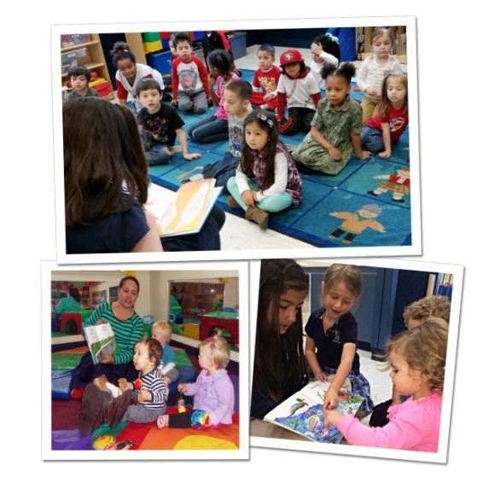
March is National Reading Month, so it is a great time to reinforce how important it is to expose children to books from an early age. We engage all of our students in language and literacy activities every day throughout the school year.
Research has shown that reading aloud to children has a profound influence on their speech development and listening skills. Reading allows children to experience the wondrous world depicted in books, and thrive on the interaction with adults.
Below are age appropriate activities that we implement in our classrooms to get children excited about reading, as well as recommended books to read with your child at home.
INFANTS – Linking sensory and reading experiences
In the classroom: We introduce language and literacy beginning with our infants, by consistently speaking, reading and singing to them. Teachers choose interactive books with bright colors, different textures and pop-up designs to help stimulate infants’ growing sensory awareness.
Books to read at home: Pat the Bunny by Dorothy Kunhardt, Fuzzy Yellow Ducklings by Matthew Van Fleet and Baby Danced the Polka by Karen Beaumont
TODDLERS – Rhyme and repetition
In the classroom: Toddlers enjoy hearing the same books read over and over again, because they are able join in as the stories become more familiar. Teachers read books with rhyme and repetition, such as Goodnight Moon, and vary their voice each time they tell the story. The change in tone gives children a chance to hear different sounds, and encourages them to practice making the sounds themselves.
Books to read at home: All Fall Down by Helen Oxenbury, Where is the Green Sheep by Mem Fox and Big Red Barn by Margaret Wise Brown
BEGINNERS – Engaging the imagination
In the classroom: Around age two, children begin to develop a love for the world of imagination. It’s important to engage children’s imaginations and encourage them to participate in shared reading experiences. A picture walk motivates children to rely on pictorial clues to decipher the story’s plot and make predictions. Before reading the story, the teacher and student flip through the book, and the child is encouraged to make predictions about the characters and plot. The teacher then reads the book aloud with the student. When finished, the child is asked to relate his predictions to the actual outcome of the story. For example, “Now that you know what happened, why was the elephant wearing a tutu?” or “What would you have done if you were the elephant?”
Books to read at home: If You Give a Mouse a Cookie by Laura Numeroff, Corduroy by Don Freeman or Bark, George by Jules Feiffer
INTERMEDIATES – Exploring the wider world
In the classroom: As our Intermediates are introduced to the Citizens of the World component of our curriculum, they read about different places, cultures and traditions in books. Books help children understand and enjoy learning about the diversity of human experience. During circle time for example, we may read a story about children living in another country, in a different type of house and wearing different types of clothes. Afterward, the teacher connects the story back to what the children know by asking, “What does your house look like?” and “Who lives in your house with you?”
Books to read at home: Abuela by Arthur Dorros, So Much by Trish Cooke and On Mother’s Lap by Ann Scott
PRE-K/PRE-K 2 – Nonfiction Adventures
In the classroom: Children are naturally fascinated by the lives of real people and the world around them. Our teachers cultivate this fascination by exposing students to nonfiction books. For example, the class may read both a fiction and nonfiction book about animals. Afterward, they are encouraged to compare and contrast the two books and discuss what was accurate in the fiction book.
Books to read at home: Stellaluna by Janell Cannon (fiction) and Bat Loves the Night by Nicola Davies (non-fiction)
By experiencing a literacy-rich environment, both at school and at home, we instill a love of reading and provide the foundation for our students to become successful, confident readers in elementary school and beyond.
- Lauren Starnes, PhD- Director of Early Childhood Education

