Embracing Diversity and the Traditions of Others
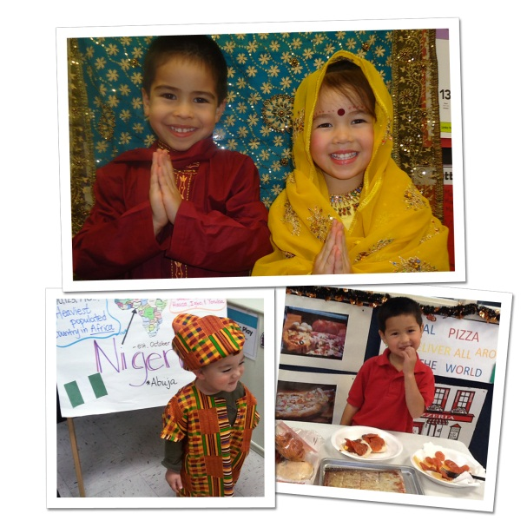
Children as young as two years old begin to notice differences among people. For instance, they may notice differences between boys and girls, or recognize that some families eat different foods or celebrate different holidays than their own family.
Research shows that children who learn to have a strong appreciation of their own family traditions and culture have an easier time appreciating the traditions and cultures of others. With this foundation, as children progress through elementary school and beyond, they have more social confidence and success in interacting with many different types of people.
Below are some ways that we focus on self-awareness and the appreciation of diverse cultures in the classroom, as well as some ideas you can try at home.
INFANTS/TODDLERS: In our classrooms, infants and toddlers look at photos of familiar people and practice pointing to and naming each person, helping them to communicate a concept of self and family.
At home, collect photos of people your baby knows, and place them where he can see and reach them. Talk about the photo with your baby. For example, “Look Jake, here’s your grandmother. Who’s she holding? That’s you, Jake!” Toddlers may be able to find and name different family members.
BEGINNERS (Ages 2-3): We introduce Spanish in our Beginner program to give children a head start on mastering a second language and understanding different cultures. In addition to Spanish language, students explore different traditions in Spanish speaking countries, such as music, musical instruments, and food.
At home, discuss your own family’s traditions with your child. Show him photos from different holidays and explain why you celebrate your traditions, such as why you go to Grandma’s house for Christmas or why you light candles for Hanukkah.
INTERMEDIATES (Ages 3-4): As children read stories about different family structures, home environments, and traditions around the world, our teachers encourage them to share their own experiences. During circle time for example, we may read a story about children living in a different country, in a different type of house and wearing a different type of clothes. Afterward, the teacher connects the story back to what the children know by asking, “What does your house look like?” and “Who lives in your house with you?”
Recommended books to read with your 3 or 4 year old include The Sneetches by Dr. Seuss, The Color of Us by Karen Katz, Why Am I Different by Norma Simon and It’s Okay to be Different by Todd Parr. After you’re done reading, share what’s unique about your child and ask him to discuss how he is different from the characters in the story.
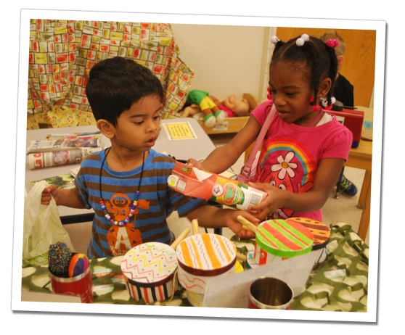
PRE-K/PRE-K 2 (Ages 4-5): Pre-K children are curious to share their experiences and learn about those of others. Our teachers cultivate this curiosity with a focus on diversity. One way is by transforming their classrooms into international markets. Parents and teachers provide food, magazines, currency and musical instruments from various countries, and children are given the opportunity to shop for items found around the world. Some schools hold a cultural block party in which families share their heritage, including traditional foods.
Recommended books to read with your child at this stage include Whoever You Are by Mem Fox and Hats Off to Hair by Virginia Kroll.
In summary, we provide many opportunities for children to build self-identity, share family traditions, and learn about diversity in the classroom and around the globe. The better children understand themselves and the world around them, the easier they will make friends, accept others and appreciate differences as they transition into elementary school and beyond.
- Lauren Starnes, PhD- Director of Early Childhood Education

